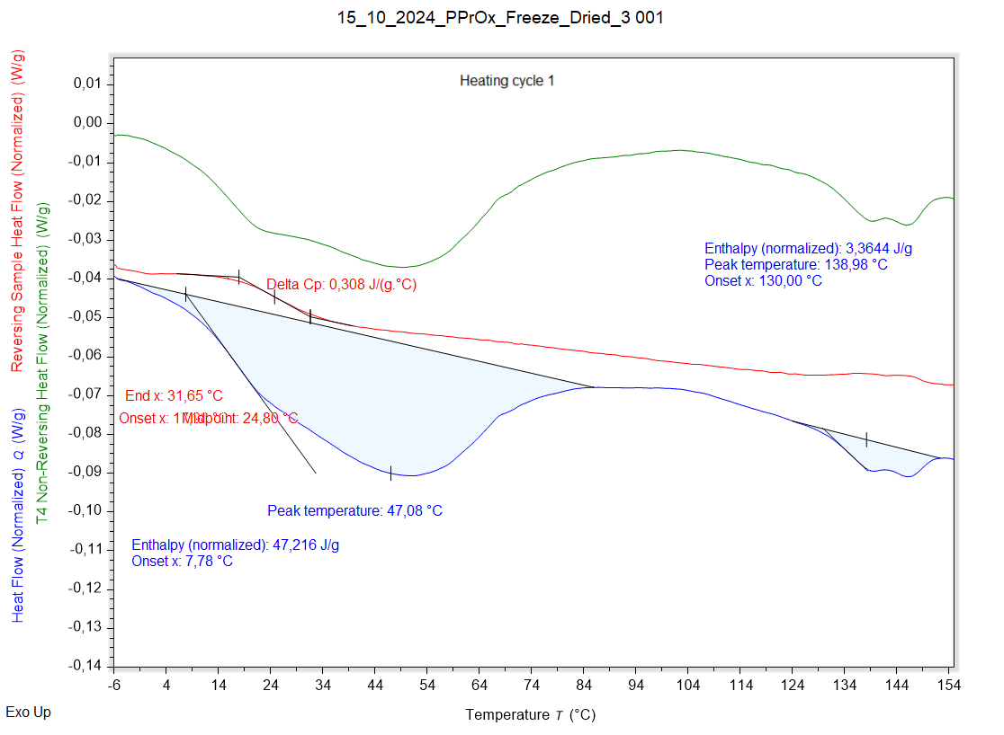

|  |  |  |  |
| --- | --- | --- | --- |
| Solvent evaporation | Solvent evaporation onset (°C) | Solvent evaporation peak (°C) | Solvent evaporation enthalpy (J/g) |
|  | 7,785 °C | 47,081 °C | 47,216 J/g |

|  |  |  |  |
| --- | --- | --- | --- |
| Melting | Melting onset (°C) | Melting peak (°C) | Melting enthalpy (J/g) |
|  | 130,004 °C | 138,979 °C | 3,3644 J/g |

|  |  |  |  |
| --- | --- | --- | --- |
| Glass transition | Glass transition onset (°C) | Glass transition endpoint (°C) | Glass transition midpoint (°C) |
|  | 17,976 °C | 31,646 °C | 24,798 °C |

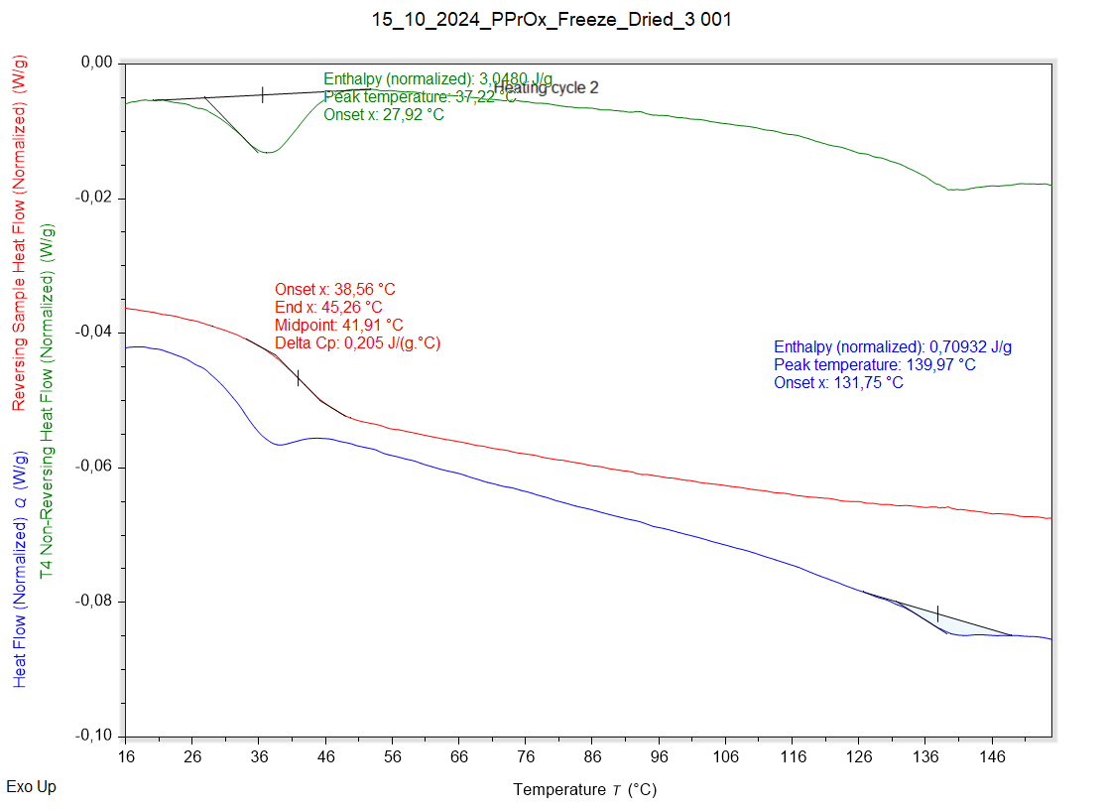

|  |  |  |  |
| --- | --- | --- | --- |
| Solvent evaporation | Solvent evaporation onset (°C) | Solvent evaporation peak (°C) | Solvent evaporation enthalpy (J/g) |
|  | 27,919 °C | 37,223 °C | 3,0480 J/g |

|  |  |  |  |
| --- | --- | --- | --- |
| Melting | Melting onset (°C) | Melting peak (°C) | Melting enthalpy (J/g) |
|  | 131,749 °C | 139,966 °C | 0,70932 J/g |

|  |  |  |  |
| --- | --- | --- | --- |
| Glass transition | Glass transition onset (°C) | Glass transition endpoint (°C) | Glass transition midpoint (°C) |
|  | 38,557 °C | 45,264 °C | 41,910 °C |